**Project Report on:**

**Online Voting System**

**Name: Devendra Kundur Date:14/04/2025**

The "Online Voting System" is a web-based platform designed to simplify the election process while ensuring security, transparency, and ease of access for all participants. The system enables eligible voters to register, log in, view candidates, and cast their votes within a predefined time window. It also allows administrators to manage users, monitor the voting process, and announce results after the completion of the voting period.

**Core Pages to Built**

1. Login Page (login.html)
2. Signup Page (signup.html)
3. Index/Dashboard Page (index.html)
4. Vote Confirmation Page (optional modal or pop-up)
5. Logout and Error Handling

**Tech Stack**

* Backend: Java with Spring Boot
* Frontend: HTML, CSS
* Database: PostgreSQL
* Build Tool: Maven
* Authentication: Simple login/signup logic
* Spring Data JPA (for DB interaction)

**Project Structure**

**├── src/**

**│ ├── main/**

**│ │ ├── java/com/voting/**

**│ │ │ ├── controller/**

**│ │ │ ├── model/**

**│ │ │ ├── repository/**

**│ │ │ ├── service/**

**│ │ │ └── OnlineVotingApplication.java**

**│ │ └── resources/**

**│├──templates/static/  
 ←HTMLpages(login,signup, index,results,voteconfirmation)**

**│ │ └── application.properties**

**├── pom.xml**

**Key Features:**

1. User Registration: Users can sign up as either a voter or a candidate by providing basic information such as username, password, mobile number, and selecting a role.
2. Secure Login: Both candidates and voters can log in to their accounts securely using their credentials.
3. Candidate Listing: The system displays a list of candidates by name on the index page, eliminating the need for candidate IDs.
4. Voting Time Restriction: Voting is only allowed between 8:00 AM and 5:00 PM. Attempts to vote outside this window result in a friendly alert, and the Vote button is disabled while the Logout option remains active.
5. Vote Submission Confirmation: Once a voter casts their vote, they are redirected to a confirmation page that thanks them for voting and informs them about the result announcement schedule.
6. Admin Role: The admin monitors the voting process, locks the results, and officially announces the winner only after 5:30 PM.
7. Mobile Number Verification: A mobile number is required during registration for identity validation, ensuring each user is genuine and unique.
8. Audit Logging: Every important user action is logged for future audit purposes to ensure transparency and security.

**OUTPUT**

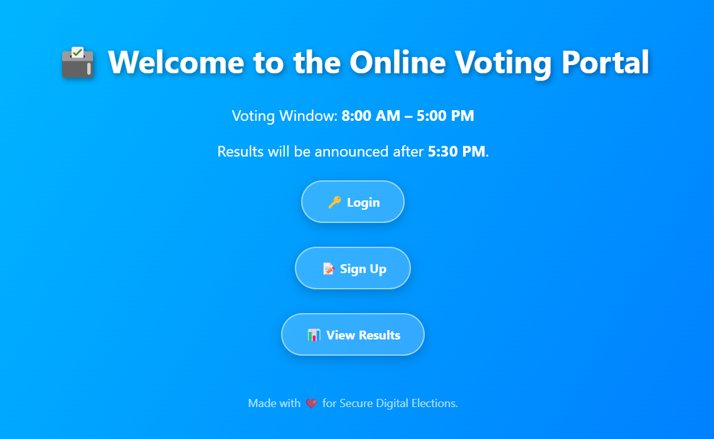

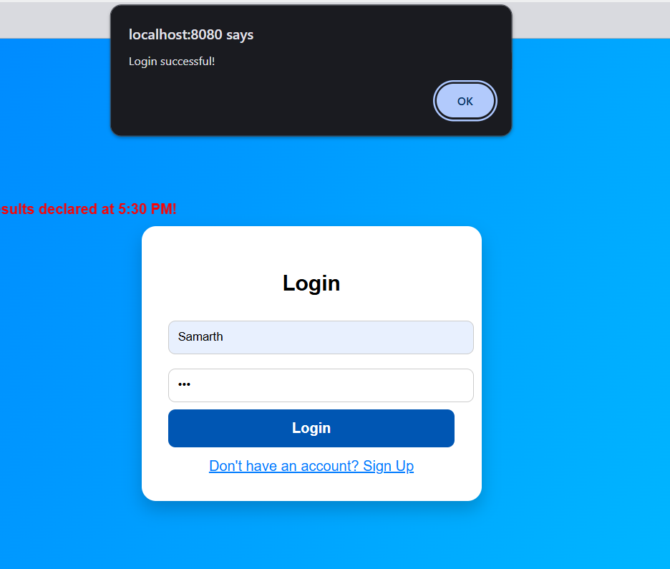

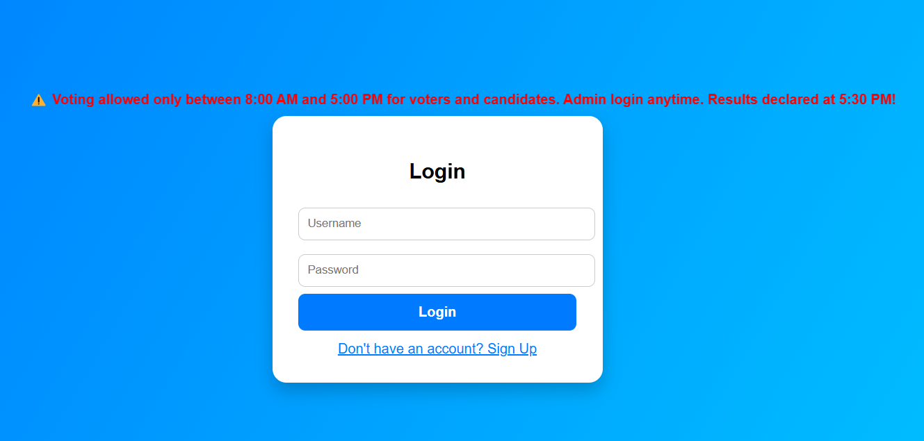

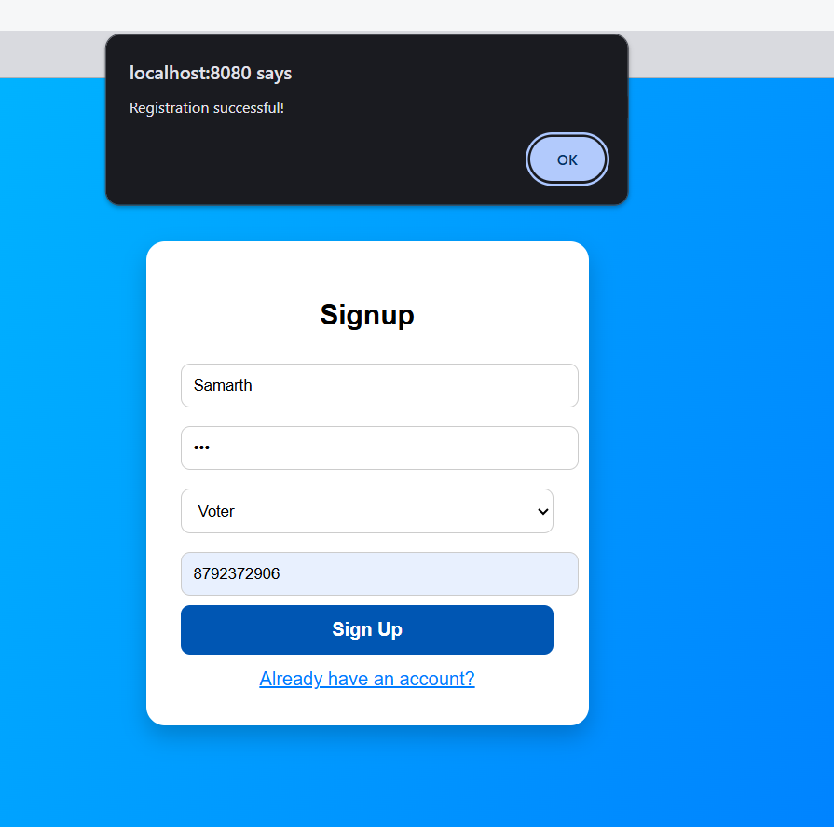

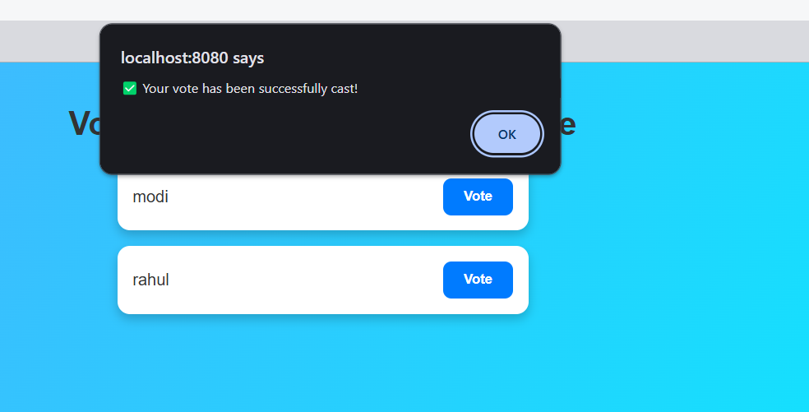

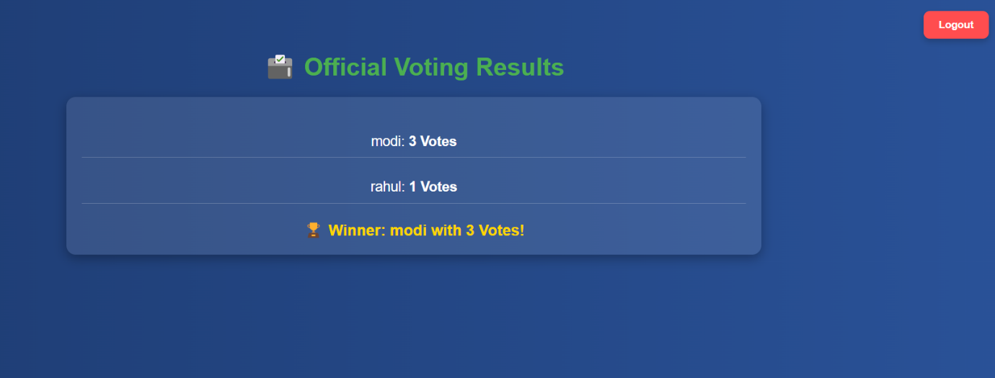

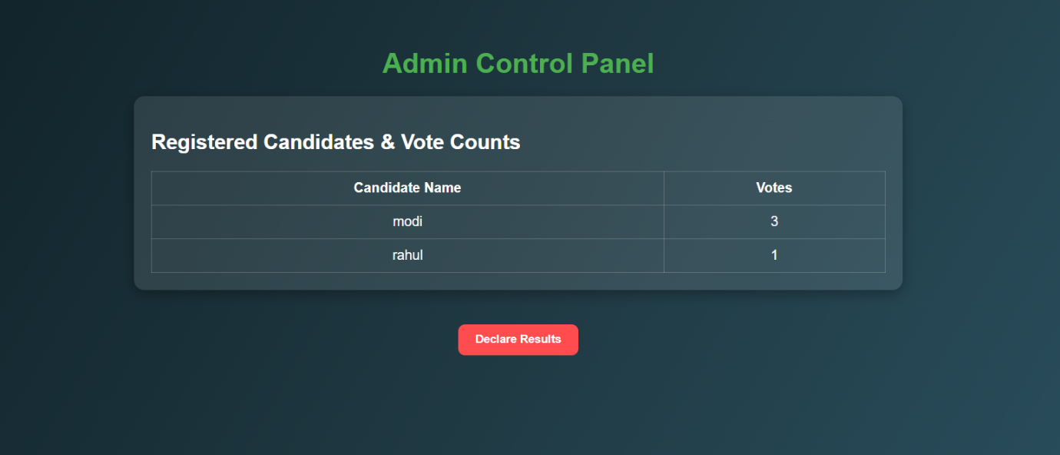

**Users Table:**

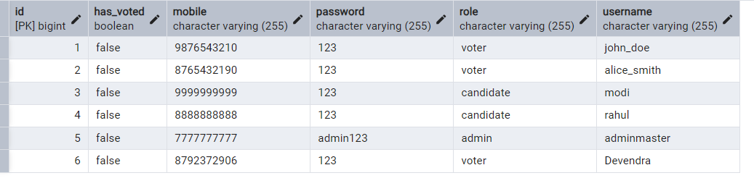

**Vote Table:**

